**TRAVEL AGENCY SYSTEM**



**A PROJECT REPORT**

*Impartial fulfillment of the requirements for the award of the degree*

###### BACHELOR OF COMPUTER APPLICATION

Under the guidance of

#### Lakhan Mahato



**EMINENT COLLEGE OF MANAGEMENT AND TECHNOLOGY** (MAULANA ABUL KALAM AZAD UNIVERSITY OF TECHNOLOGY, WEST

BENGAL)

IN ASSOCIATION WITH

**(ISO9001:2015)**

SDF Building, Module#132,GroundFloor,SaltLakeCity, GP Block,SectorV,Kolkata,WestBengal700091

1. Title of the Project: **TRAVEL AGENCY SYSTEM**
2. Project Members: **SOURAV PRAMANICK**

**SK MIKAIL**

**SUBHASHREE KARMAKAR**

**SOVAN SAHA**

1. Name of the guide: **Mr.Lakhan Mahato**
2. Address: Ardent Computech Pvt.Ltd (An ISO 9001:2015 Certified) SDFBuilding, Module#132,GroundFloor,SaltLake City,GPBlock,SectorV,Kolkata,WestBengal- 700091

***Project Version Control History***

|  |  |  |  |
| --- | --- | --- | --- |
| **Version** | **Primary Author** | **Description of Version** | **Date Complete** |
| **Final** | **SOURAV PRAMANICK**  **SK MIKAIL**  **SUBHASHREE KARMAKAR**  **SOVON SAHA** | **Project Report** | **20THOCT,2022** |

Signature of Team Member Signature of Approver

Date: Date:

For Office Use Only **Mr.Lakhan Mahato**



**DECLARATION**

We hereby declare that the project work being presented in the project proposal entitled **“TRAVEL AGENCY SYSTEM”** in partial fulfillment of the requirements for the award of the degree of **BACHELOR OF COMPUTER APPLICATION** at **ARDENT COMPUTECH PVT.LTD, SALTLAKE, KOLKATA, WEST BENGAL,** is an authentic work carried out under the guidance of **Mr.Lakhan Mahato**. The matter embodied in this project work has not been submitted elsewhere for the award of any degree of our knowledge and belief.

**Date:**

**Name of the Users:**

**SOURAV PRAMANICK**

**SK MIKAIL**

**SUBHASHREE KARMAKAR**

**SOVON SAHA**

***Signature of the users:***

**Ardent Computech Pvt.Ltd(AnISO9001:2015 Certified)** SDFBuilding,Module#132,GroundFloor,SaltLakeCity,GPBlock,SectorV,Kolkata,WestBengal70 0091

**CERTIFICATE**

This is to certify that this proposal of minor project entitled **“TRAVEL AGENCY SYSTEM”** is a record of bona fide work, carried out by **SOURAV PRAMANICK, SK MIKAIL , SUBHASHREE KARMAKAR, SOVON SAHA** under my guidance at **ARDENTCOMPUTECH PVT LTD**. In my opinion, the report in its present form is in partial fulfillment of the requirements for the award of t he degree of **BACHELOROFCOMPUTERAPPLICATION** and as per regulations of the **ARDENT*®.*** To the best of my knowledge, the results embodied in this report, are original in nature and worthy of incorporation in the present version of the report.

**Guide /Supervisor**

###### MR.Lakhan Mahato

Project Engineer

Ardent Computech Pvt.Ltd (AnISO9001:2015Certified)

SDFBuilding,Module#132,GroundFloor,SaltLakeCity, GP Block,SectorV,Kolkata,WestBengal700091

**ACKNOWLEDGEMENT**

This project work was undertaken for partial fulfillment of the course of Bachelor of Computer Application under EMINENT COLLEGE OF MANAGEMENT & TECHNOLOGY. I also want to show our greatest appreciation to ***Prof. Lakhan Mahato***, Project Engineer at Ardent, Kolkata for helping me to understand the bottom line of the system i.e. how the internal works are carried out in **TRAVEL AGENCY SYSTEM** for taking online exam of users.

***BCA***

***EMINENT COLLEGE OF MANAGEMENT & TECHNOLOGY***

***5thsemister***

###### TABLEOFCONTENTS

Abstract 7

1. INTRODUCTION 8
   1. PROJECTAIMS ANDOBJECTIVE 8
   2. BACKGROUNDOF PROJECT 9
   3. OPERATIONENVIRONMENT 10
2. SYSTEMANALYSIS 11
   1. SOFTWAREREQUIREMENTSPECIFICATION 11
   2. EXISTINGVSPROPOSED 17
   3. SOFTWARETOOLUSED 18
3. SYSTEMDESIGN 20
   1. DATAFLOW DIAGRAM 20
4. SYSTEMIMPLEMENTATION 29
   1. SCREEN SHORTS 29
   2. CODING 34
5. SYSTEMTESTING 72
   1. UNITTESTING 72
   2. INTEGRATION TESTING 75
6. CONCLUSION&FETURESCOPE 76
7. REFERENCES 77

# Abstract

This project “**TRAVEL AGENCY SYSTEM**” is used to automate all process of the travel and tourism, which deals with creation, booking and confirmation and user details. The project is designed HTML, CSS, JAVA Script as front which works in any browsers. The coding language used HTML. Travel and tourism management system is used to book a tour from anywhere in the world by a single dynamic website which will help the user to know all about the places and tour details in a single website. The admin can add packages to the website from a certain travel agents and hotels by create a tour page. Then the users can sign in and book each project, they can be confirmed by the admin in their manage booking page. The user can see the confirmation in my booking page. It is an easiest platform for all travelers which can be easily booked and know the all details.

Keywords: Travel and tourism management, travel packages, tourism, package booking

.

**CHAPTER1**

#### INTRODUCTION

This chapter gives an overview about the aim, objectives, background and operation environment of the system.

#### PROJECTAIMSANDOBJECTIVE

The main objective of the Project on Travel Website is to manage the details of Travel, Tour, Agent, Hotel, Facility. It manages all the information about Travel, Customer, Facility, Travel. The project is totally built at administrative end and thus only the administrator is guaranteed the access. The purpose of the project is to build an application program to reduce the manual work for managing the Travel, Tour. The aim sand objectives are as follows:

* Provides the searching facilities based on various factors. Such as Travel, Agent,
* Hotel, Facility
* Travel Website also manage the Customer details online for Hotel details, Facility
* details, Travel.
* It tracks all the information of Tour, Customer, Hotel etc.
* Manage the information of Tour.
* Shows the information and description of the Travel, Agents.
* To increase efficiency of managing the Travel, Tour.
* It deals with monitoring the information and transactions of hotel.
* Manage the information of Travel.
* Editing, adding and updating of Records is improved which results in proper
* resource management of Travel data.
* Manage the information of hotel.
* Integration of all records of Facility.

### . BACKGROUND OF PROJECT

In the world of Internet, Whole information is scattered. It contains a lot of information but generally, we require only a handful of information. Our daily activities on internet revolve around a few basic websites. We don’t know how to extract necessary information from the vast Internet, or else even if we know how to extract, we spend a lot of time in finding the information. No website on Internet is flexible enough to meet all the basic needs of any Internet user. General queries of customer range from finding solution to a code to booting a system.

* 1. **OPERATION ENVIRONMENT**

|  |  |
| --- | --- |
| PROCESSOR | RYAZON 5 PROCESSOR |
| OPERATINGSYSTEM | WINDOWS10 |
| MEMORY | 8 GB RAM |
| HARDDISKSPACE | 1 TB |

**CHAPTER2**

#### SYSTEMANALYSIS

In this chapter, we will discuss and analyze about the developing process

of Travel Agency System including software requirement specification (SRS) and comparison between existing and proposed system. The functional and non- functional requirements are included in SRS part to provide completed scription and overview of system requirement before the developing process is carried out.

Besides that, existing vs proposed provides a view of how the proposed system will be more efficient than the existing one.

#### SOFTWAREREQUIREMENTSPECIFICATION

###### GENERALDESCRIPTION

PRODUCTDESCRIPTION:

Travel Agency System is a computerized system which helps user to manage the Restaurant daily activity in electronic format. It reduces the risk of paperwork such as file lost, file damaged and time consuming. It can help user to manage the transaction or record more effectively and time-saving.

PROBLEMSTATEMENT:

The problem occurred before having computerized system includes:

* + - * File lost

When computerized system is not implemented file is always lost because of human environment. Sometimes due to some Human error there may be a loss of records.

* + - * File damaged

When a computerized system is not there file is always lost due to some accident like spilling of water by some member on file accidentally. Besidessomenaturaldisasterlikefloodsorfiresmayalsodamagethefiles.

* + - * Difficult to search record when there is a difficulty in searching of records if the records are large in number.
      * Space consuming after the number of records become large the space for physical storage of file and records also increases if no computerized system is implemented.
      * Cost consuming as there is no computerized system them to add each record paper will be needed which will increase the cost for them an agreement of Travel Agency .
    1. **SYSTEMOBJECTIVE**
       - Improvement in control and performance. The system is developed to cope up with the current orders and problems of Travel Agency . The system can a dd user, validate user and is also bug free.
       - Save cost after computerized system is implemented less human force will b e required to maintain the Travel agency thus reducing the overall cost.
       - Save time User is able to search record by using few clicks of mouse and fews earch keywords thus saving his valuable time.

 

#### SYSTEMREQUIREMENTS

* + - 1. NON-FUNCTIONALREQUIREMENTS
         * Product Requirements

EFFICIENCYR EQUIREMENT

When a Restaurant management system will be implemented user and user will easily access Travel searching and food order transaction will be very faster.

RELIABILITY REQUIREMENT

The system should accurately perform member registration, member validation, report generation, reservation, hotel booking and search.

USABILITYREQUIREMENT

The system is designed for a user-friendly environment so that user and staff of Travel can perform the various tasks easily and in an effective way.

ORGANIZATIONALREQUIREMENT

IMPLEMENTATIONREQUIREMNTS

In implementing whole system it uses html in front end.

ELIVERYREQUIREMENTS

The whole system is expected to be delivered in one month of time with a weekly evaluation by the project guide.

* + - 1. FUNCTIONALREQUIREMENTS

1. NORMALUSER

USERLOGIN

Description of feature

This feature used by the user to login in to system. They are required to book user id

and password before they are allowed to book the system. The user id and password will be verified and if invalid is the reuser is allowed to not order the system.

Functional requirements

-user id is provided when they register

-The system must only allow user with valid id and password to order the system

-The system performs authorization process which decides what user level can access to.

-The user must be able to logout after they finished using system.

* 1. REGISTERNEWUSER Description of feature

This feature can be performed by all users to register new user to create account.

Functional requirements

-System must be able to verify in formation

-System must be able to delete information if information is wrong

* 1. ADVANTURE IDEA

Descriptionof feature

This feature gives new adventure ideas.

* 1. FEATURED PRODUCTS

DESCRIPITION OF FEATURE

This feature is to sales product which are use to traveling.

* 1. POPULAR PACKAGES

DESCRIPITION OF FEATURE

This feature is giving you best packages.

SOFTWAREANDHARDWAREREQUIREMENTS

Thissectiondescribesthesoftwareandhardwarerequirementsofthesystem.

* + - 1. SOFTWAREREQUIREMENTS
         * Operating system- Windows10 is used as the operating system as it is stable and supports more features and is more user friendly.
         * Development tools and Programming language- HTML is used to write the whole code and develop webpages with css, java script for styling .
      2. HARDWAREREQUIREMENTS
* Ryzon 5 is used as a processor because it is fast than other processors an provide reliable and stable and we can run our pc for long time. By using this process or we can keep on developing our project with out any worries.
* Ram 8gb is used as it will provide fast reading and writing capabilities and will in tur n supporting processing.

#### EXISTING VS PROPOSED

1. Existing system does not have any facility of login or user login where as proposed system will have a facility Of user login.
2. Existing system does not have a facility of online reservation whereas proposed system has a facility of online reservation.
3. Existing system does not have any facility of online notice board where description of workshops happening in our college as well as near by colleges is being provided.
4. Existing system does not have any facility to generate user reports as well order reports whereas proposed system provides user with a tool to generate reports.
5. Existing system does not has any facility for food request and suggestions where as in proposed system after logging in to their accounts user can request bookish na as well as provide suggestions to improve travel agency

.

#### SOFTWARETOOLUSED

The whole Project is base on the frontend

* + 1. Frontend The frontend is designed using of html, css, Java script.

**HTML-** HTML is an acronym which stands for **Hyper Text Markup Language** which is used for creating web page sand web applications. Let's see what is meant by Hypertext Markup Language, and Webpage.

**Hyper Text:** Hyper Text simply means "Text within Text." A text has a link within it, is a hyper text. Whenever you click on a link which brings you to an web page, you have clicked on a hypertext. Hyper Text is a way to link two or more webpages (HTML documents) with each other.

**Markup language:** A markup language is a computer language that is used to apply layout and formatting conventions to a text document. Markup language makes text more interactive and dynamic. It can turn text into images, tables, links, etc.

**Web Page:** A web page is a document which is commonly written in HTML and translated by a web browser. A web page can be identified by ordering an URL. A Web page can be of the static or dynamic type. **With the help of HTML only, we can create static webpages**.

Hence, HTML is a markup language which is used for creating attractive web pages with the help of styling, and which looks in an information web browser. An HTML document is made of many HTML tags and each HTML tag contains different content.

**CSS- Cascading Style Sheets** (**CSS**) is a style sheet language used for describing the look and formatting of a document written in a markup language. While most often used to style web pages and interfaces written in HTML and XHTML, the language can be applied to any kind of XML document, including plain XML, SVG and XU L.CSS is a cornerstone specification of the web and almost all web pages use CSS style sheets to describe the representation. CSS is designed primarily to enable this parathion of document content from document presentation, including elements such as the layout, colors, and fonts. This separation can improve content accessibility, provide more flexibility and control in the specification.

**JAVA SCRIPT-** Java is a **programming language** and a **platform**. Java is a high level, robust, object-oriented and secure programming language.

Java was developed by *Sun Microsystems* (which is now the subsidiary of Oracle) in the year 1995. *James Gosling* is known as the father of Java. Before Java, its name was *Oak*. Since Oak was already a registered company, so James Gosling and his team changed the name from Oak to Java.

**Platform**: Any hardware or software environment in which a program runs is known as a platform. Since Java has a run time environment (JRE)and API, it is called a platform.

**CHAPTER3**

**DATA FLOW DIAGRAM**

What is data flow diagram?

A Data Flow Diagram (DFD)is a traditional visual representation of the information flows within a system. A neat and clear DFD can depict the right amount of the system requirement graphically.

It can be manual, automated, ora combination of both.

Its how show data orders and leaves the system, what changes the information, and where data is stored.

The objective of a DFD is to show the scope and boundaries of a system as a whole. It may be used as a communication tool between a system analyst and any person who plays a part in the order that acts as a starting point for redesigning a system. The DFD is also called as a dataflow graph or bubble chart.

**The following observations about DFDs are essential:**

* + - 1. All names should be unique. This makes it easier to refer to elements in the DFD.
      2. Remember that DFD is not a flowchart. Arrows is a flowchart that represents the order of events; arrows in DFD represents flowing data. A DFD doe s not in volve any order of events.
      3. Suppress logical decisions. If we ever have the urge to draw a diamond-shaped box in a DFD, suppress that urge! A diamond- shaped box is used in flow charts to represents decision points with multiple exists paths of which the only one is taken. This implies an order in g of events, which makes no sense in a DFD. Do not become bogged down with details. Defer error conditions and error handling until the end of the analysis.

**Standard symbols for DFDs are derived from the electric circuit diagram analysis and are showning:**

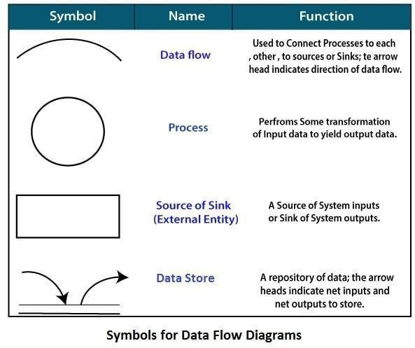

**Circle:** A circle (bubble) shows a process that transforms data inputs in to data outputs.

**Data Flow:** A curved line shows the flow of data into or out of a process or datastore.

**Data Store:** A set of parallel lines shows a place for the collection of data items. A datastore indicates that the data is stored which can be use data later stage or by the other processes in a different order. The data store can have an element or group of elements.

**Source or Sink:** Source or Sink is an external entity and acts as Source of system inputs or sink of system outputs.

#### DATAFLOW DIAGRAM FOR USER AND ADMIN

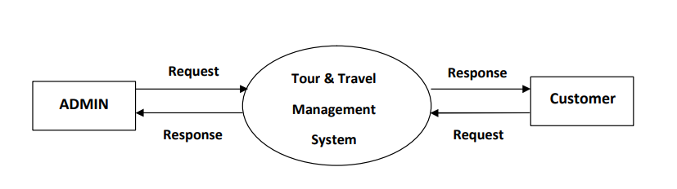

#### USECASE DIAGRAMFORUSER AND ADMIN

#### 

#### SEQUENCE DIAGRAM

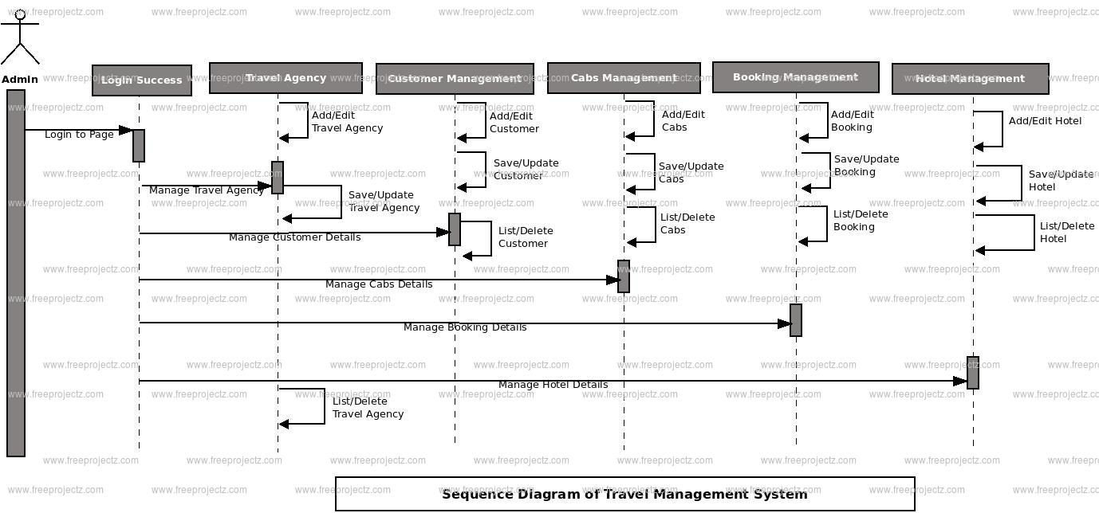

**CHAPTER4**

#### SYSTEMIMPLEMENTATION

* 1. **SCREENSHORTS**

###### UserInterfaceDesign

**HomePage:**

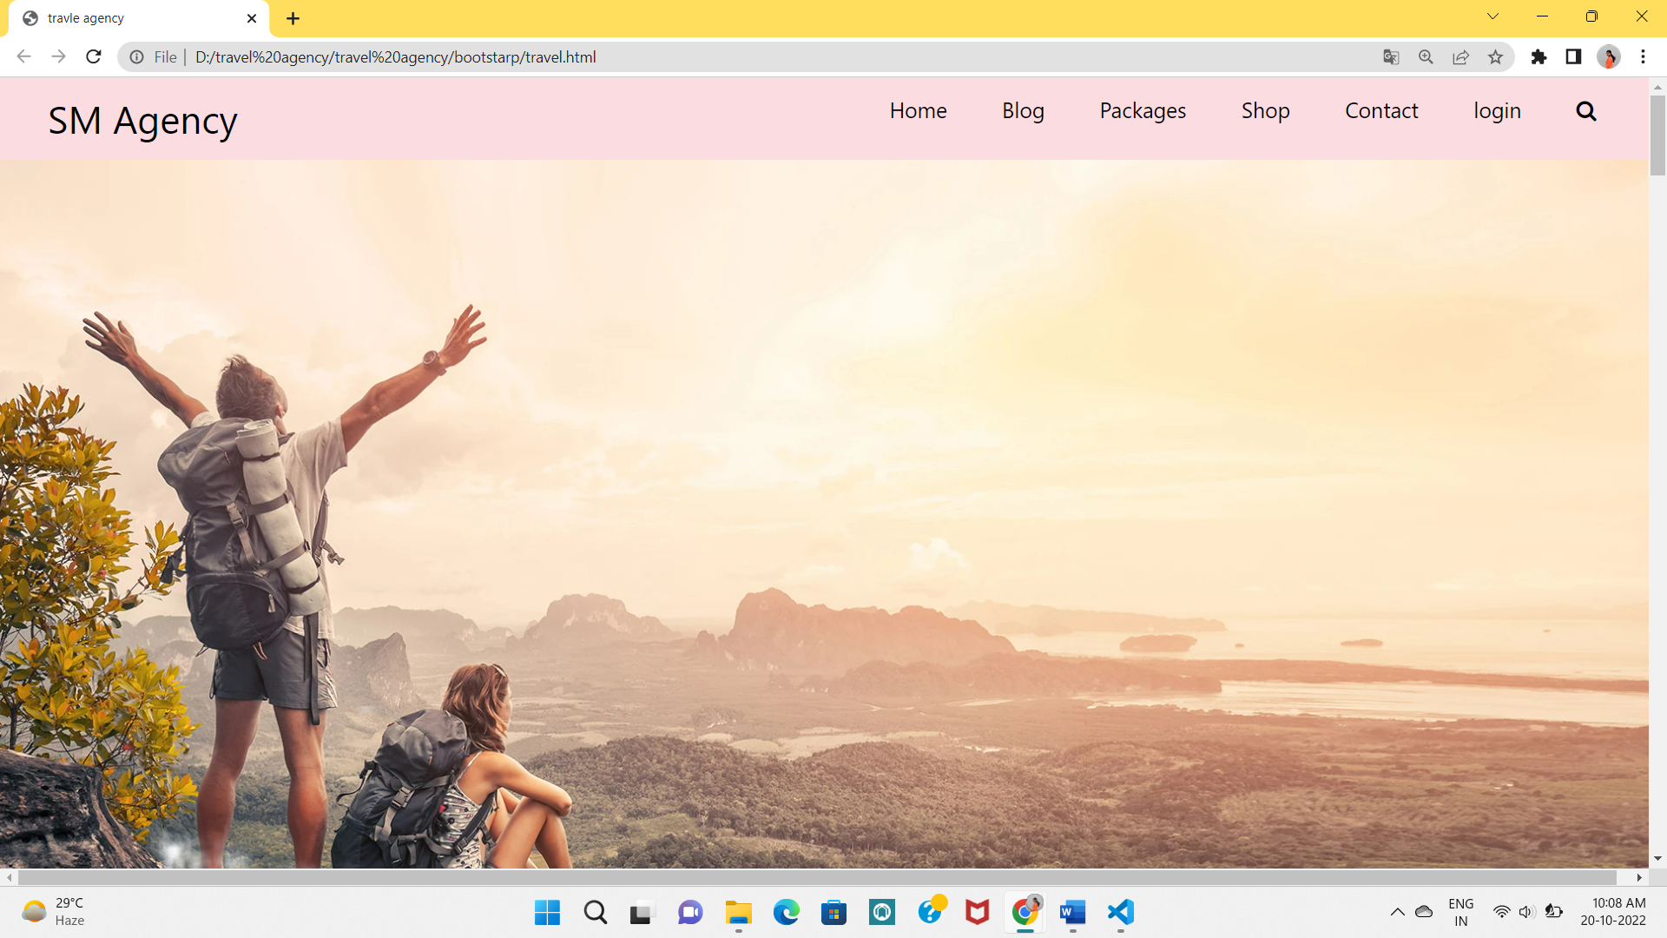

###### Advanture Idea Page:

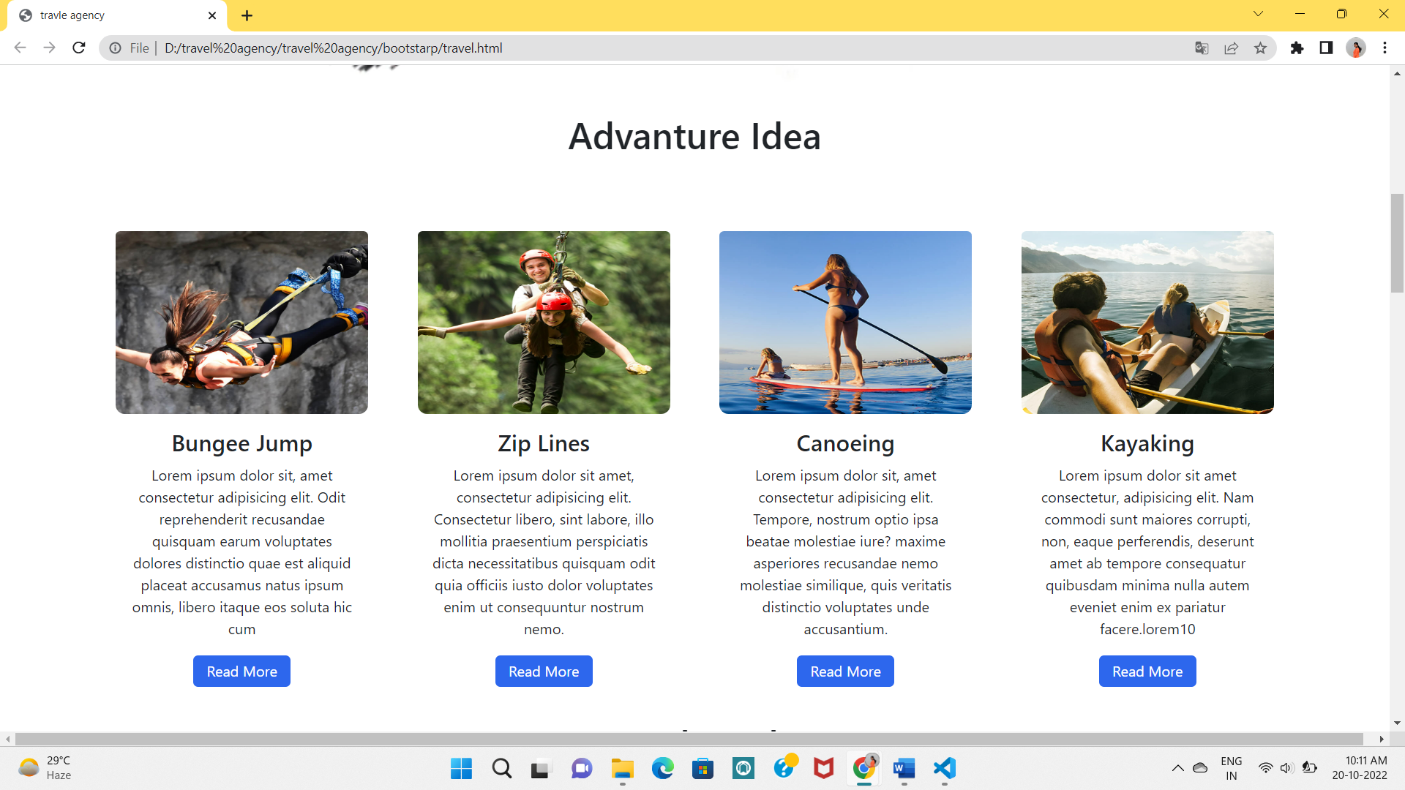

**Featured Product Page:**

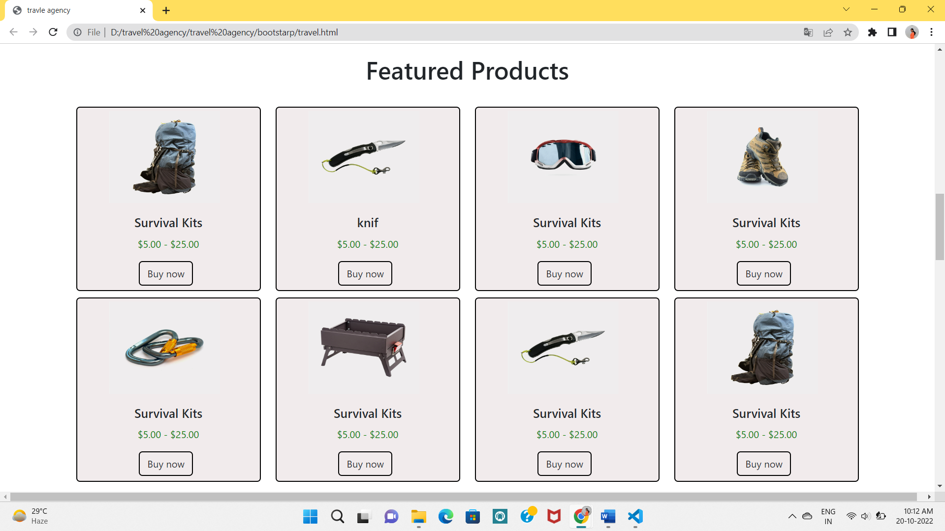

###### Popular Packages Page:

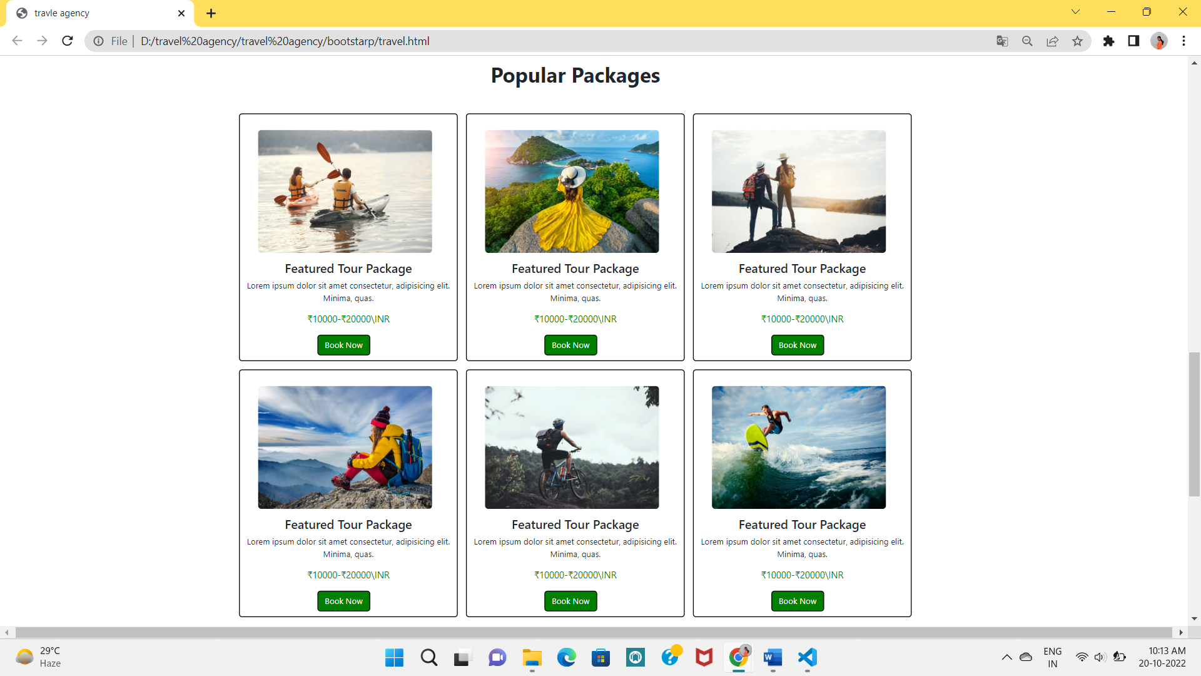

**What we offer Page:**

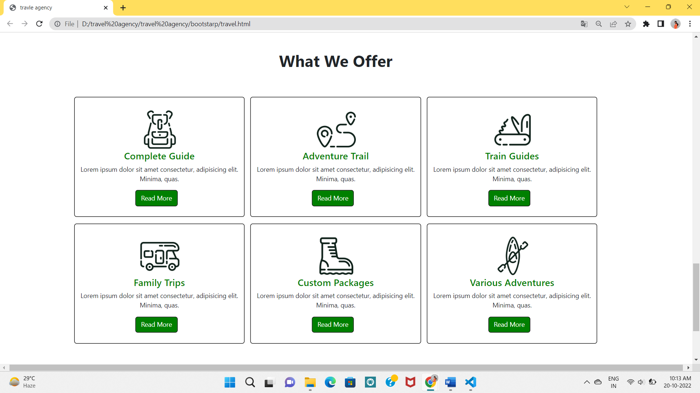

**3.2 Cooding:**

**Home page:**

<!DOCTYPE html>

<html lang="en">

<head>

  <meta charset="UTF-8">

  <meta http-equiv="X-UA-Compatible" content="IE=edge">

  <meta name="viewport" content="width=device-width, initial-scale=1.0">

  <title>travle agency</title>

  <link rel="stylesheet" href="https://stackpath.bootstrapcdn.com/font-awesome/4.7.0/css/font-awesome.min.css">

  <link rel="stylesheet" href="tstyle.css">

  <link rel="stylesheet" href="css/bootstrap.min.css">

</head>

<!-- header -->

<body>

  <nav class="navbar">

    <div class="logo">SM Agency</div>

    <ul class="nav-links">

      <input type="checkbox" id="checkbox_toggle" />

      <label for="checkbox_toggle" class="hamburger">&#9776;</label>

      <div class="menu">

        <li><a href="#">Home</a></li>

        <li><a href="#">Blog</a></li>

        <li> <a href="#">Packages</a></li>

        <li><a href="#">Shop</a></li>

        <li><a href="#">Contact</a></li>

        <li><a href="login\index.html">login</a></li>

        <li><i class="fa fa-search" aria-hidden="true"></i></li>

      </div>

    </ul>

  </nav>

  <div class="row   class-img">

    <img src="images/home-bg-3.jpg" alt="" height="100% " width="100%">

   </div>

   <!-- header end -->

   <!-- body1 -->

   <div class="row advanture-idea">

    <div class="col-12 ">

      <h1>Advanture Idea</h1>

    </div>

   </div>

  </div>

  <!-- body 1 end -->

  <!--Advanture Idea  -->

<div class="container">

    <div class="row idea">

      <div class="card col-12 col-md-3 col-sm-3 ">

        <img class="card-img-top" src="images/category-1.jpg" alt="...">

        <div class="card-body">

          <h5 class="card-title11">Bungee Jump</h5>

          <p class="card-text">Lorem ipsum dolor sit, amet consectetur adipisicing elit. Odit reprehenderit recusandae

            quisquam earum voluptates dolores distinctio quae est aliquid placeat accusamus natus ipsum omnis, libero

            itaque eos soluta hic cum</p>

          <a href="#" class="btn-ai">Read More</a>

        </div>

      </div>

      <div class="card col-12 col-md-3 col-sm-3">

        <img src="images/category-2.jpg" class="card-img-top" alt="...">

        <div class="card-body">

          <h5 class="card-title11">Zip Lines</h5>

          <p class="card-text">Lorem ipsum dolor sit amet, consectetur adipisicing elit. Consectetur libero, sint

            labore, illo mollitia praesentium perspiciatis dicta necessitatibus quisquam odit quia officiis iusto dolor

            voluptates enim ut consequuntur nostrum nemo.</p>

          <a href="#" class="btn-ai">Read More</a>

        </div>

      </div>

      <div class="card col-12 col-md-3 col-sm-3">

        <img src="images/category-3.jpg" class="card-img-top" alt="...">

        <div class="card-body">

          <h5 class="card-title11">Canoeing</h5>

          <p class="card-text">Lorem ipsum dolor sit, amet consectetur adipisicing elit. Tempore, nostrum optio ipsa

            beatae molestiae iure? maxime asperiores recusandae nemo molestiae similique, quis veritatis distinctio

            voluptates unde accusantium.</p>

          <a href="#" class="btn-ai">Read More</a>

        </div>

      </div>

      <div class="card col-12 col-md-3 col-sm-3">

        <img src="images/category-4.jpg" class="card-img-top" alt="...">

        <div class="card-body">

          <h5 class="card-title11">Kayaking</h5>

          <p class="card-text">Lorem ipsum dolor sit amet consectetur, adipisicing elit. Nam commodi sunt maiores

            corrupti, non, eaque perferendis, deserunt amet ab tempore consequatur quibusdam minima nulla autem eveniet

            enim ex pariatur facere.lorem10

          </p>

          <a href="#" class="btn-ai">Read More</a>

        </div>

      </div>

    </div>

    <!-- Advanture Idea end -->

<!-- shop -->

<div class="container">

  <div class="row space">

    <h1>Featured Products</h1>

  </div>

</div>

<div class="container">

        <div class="row shop">

          <div class="card col-12 col-md-2 col-sm-2 card-1">

            <img src="images/product-1.jpg" class="card-img-top2" alt="...">

            <div class="card-body">

              <p class="card-title">Survival Kits</p>

              <p class="card-title2">

                $5.00 - $25.00</p>

              <a href="#" class="btn">Buy now</a>

            </div>

          </div>

          <div class="card col-12 col-md-2 col-sm-2 card-1" >

            <img src="images/product-2.jpg" class="card-img-top2" alt="...">

            <div class="card-body">

              <p class="card-title">knif</p>

              <p class="card-title2">

                $5.00 - $25.00</p>

              <a href="#" class="btn">Buy now</a>

            </div>

          </div>

          <div class="card col-12 col-md-2 col-sm-2 card-1">

            <img src="images/product-3.jpg" class="card-img-top2" alt="...">

            <div class="card-body">

              <p class="card-title">Survival Kits</p>

              <p class="card-title2">

                $5.00 - $25.00</p>

              <a href="#" class="btn">Buy now</a>

            </div>

          </div>

          <div class="card col-12 col-md-2 col-sm-2 card-1">

            <img src="images/product-4.JPG" class="card-img-top2" alt="...">

            <div class="card-body">

              <p class="card-title">Survival Kits</p>

              <p class="card-title2">

                $5.00 - $25.00</p>

              <a href="#" class="btn">Buy now</a>

            </div>

          </div>

          <div class="card col-12 col-md-2 col-sm-2 card-1">

            <img src="images/product-5.jpg" class="card-img-top2" alt="...">

            <div class="card-body">

              <p class="card-title">Survival Kits</p>

              <p class="card-title2">

                $5.00 - $25.00</p>

              <a href="#" class="btn">Buy now</a>

            </div>

          </div>

          <div class="card col-12 col-md-2 col-sm-2 card-1">

            <img src="images/product-6.jpg" class="card-img-top2" alt="...">

            <div class="card-body">

              <p class="card-title">Survival Kits</p>

              <p class="card-title2">

                $5.00 - $25.00</p>

              <a href="#" class="btn">Buy now</a>

            </div>

          </div>

          <div class="card col-12 col-md-2 col-sm-2 card-1">

            <img src="images/product-2.jpg" class="card-img-top2" alt="...">

            <div class="card-body">

              <p class="card-title">Survival Kits</p>

              <p class="card-title2">

                $5.00 - $25.00</p>

              <a href="#" class="btn">Buy now</a>

            </div>

          </div>

          <div class="card col-12 col-md-2 col-sm-2 card-1">

            <img src="images/product-1.jpg" class="card-img-top2" alt="...">

            <div class="card-body">

              <p class="card-title">Survival Kits</p>

              <p class="card-title2">

                $5.00 - $25.00</p>

              <a href="#" class="btn">Buy now</a>

            </div>

          </div>

        </div>

       </div>

       <div class="row gap"></div>

  </div>

  <!-- shop end -->

<div class="container">

  <div class="packages">

    <div class="row packages-1">

      <h1>Popular Packages</h1>

    </div>

    <div class="row">

      <div class="card col-12 col-md-3 col-sm-4 pac-1">

        <img  src="images\img-1.jpg" alt="">

        <div class="card-body3">

          <h4 class="card-title3">Featured Tour Package</h4>

          <p class="card-text">Lorem ipsum dolor sit amet consectetur, adipisicing elit. Minima, quas.</p>

          <p class="rs">₹10000-₹20000\INR</p>

          <a href="#" class="btn b-2">Book Now</a>

        </div>

      </div>

      <div class="card col-12 col-md-3 col-sm-4 pac-1">

        <img  src="images\img-2.jpg" alt="">

        <div class="card-body3">

          <h4 class="card-title3">Featured Tour Package</h4>

          <p class="card-text">Lorem ipsum dolor sit amet consectetur, adipisicing elit. Minima, quas.</p>

          <p class="rs">₹10000-₹20000\INR</p>

          <a href="#" class="btn b-2">Book Now</a>

        </div>

      </div>

      <div class="card col-12 col-md-3 col-sm-4 pac-1">

        <img  src="images\img-3.jpg" alt="">

        <div class="card-body3">

          <h4 class="card-title3">Featured Tour Package</h4>

          <p class="card-text">Lorem ipsum dolor sit amet consectetur, adipisicing elit. Minima, quas.</p>

          <p class="rs">₹10000-₹20000\INR</p>

          <a href="#" class="btn b-2">Book Now</a>

        </div>

      </div>

      <div class="card col-12 col-md-3 col-sm-4  mt-3 pac-1">

        <img  src="images\img-4.jpg" alt="">

        <div class="card-body3">

          <h4 class="card-title3">Featured Tour Package</h4>

          <p class="card-text">Lorem ipsum dolor sit amet consectetur, adipisicing elit. Minima, quas.</p>

          <p class="rs">₹10000-₹20000\INR</p>

          <a href="#" class="btn b-2">Book Now</a>

        </div>

      </div>

      <div class="card col-12 col-md-3 col-sm-4 mt-3 pac-1">

        <img  src="images\img-6.jpg" alt="">

        <div class="card-body3">

          <h4 class="card-title3">Featured Tour Package</h4>

          <p class="card-text">Lorem ipsum dolor sit amet consectetur, adipisicing elit. Minima, quas.</p>

          <p class="rs">₹10000-₹20000\INR</p>

          <a href="#" class="btn b-2">Book Now</a>

        </div>

      </div>

      <div class="card col-12 col-md-3 col-sm-4  mt-3 pac-1">

        <img  src="images\img-5.jpg" alt="">

        <div class="card-body3">

          <h4 class="card-title3">Featured Tour Package</h4>

          <p class="card-text">Lorem ipsum dolor sit amet consectetur, adipisicing elit. Minima, quas.</p>

          <p class="rs">₹10000-₹20000\INR</p>

          <a href="#" class="btn b-2">Book Now</a>

        </div>

      </div>

    </div>

  </div>

<div class="gap"></div>

</div>

<!-- offer section -->

<div class="container">

 <div class="offer">

    <div class="row packages-1">

      <h1>What We Offer</h1>

    </div>

    <div class="row">

      <div class="card col-12 col-md-4 col-sm-4  mt-3 pac-2">

        <img  src="images\serv-1.png" alt="">

        <div class="card-body4">

          <h4 class="card-title4">Complete Guide</h4>

          <p class="card-text">Lorem ipsum dolor sit amet consectetur, adipisicing elit. Minima, quas.</p>

          <a href="#" class="btn b-2">Read More</a>

        </div>

      </div>

      <div class="card col-12 col-md-4 col-sm-4  mt-3 pac-2">

        <img  src="images\serv-5.png" alt="">

        <div class="card-body4">

          <h4 class="card-title4">Adventure Trail</h4>

          <p class="card-text">Lorem ipsum dolor sit amet consectetur, adipisicing elit. Minima, quas.</p>

          <a href="#" class="btn b-2">Read More</a>

        </div>

      </div>

      <div class="card col-12 col-md-4 col-sm-4  mt-3 pac-2">

        <img  src="images\serv-4.png" alt="">

        <div class="card-body4">

          <h4 class="card-title4">Train Guides</h4>

          <p class="card-text">Lorem ipsum dolor sit amet consectetur, adipisicing elit. Minima, quas.</p>

          <a href="#" class="btn b-2">Read More</a>

        </div>

      </div>

      <div class="card col-12 col-md-4 col-sm-4  mt-3 pac-2">

        <img  src="images\serv-3.png" alt="">

        <div class="card-body4">

          <h4 class="card-title4">Family Trips</h4>

          <p class="card-text">Lorem ipsum dolor sit amet consectetur, adipisicing elit. Minima, quas.</p>

          <a href="#" class="btn b-2">Read More</a>

        </div>

      </div>

      <div class="card col-12 col-md-4 col-sm-4  mt-3 pac-2">

        <img  src="images\serv-2.png" alt="">

        <div class="card-body4">

          <h4 class="card-title4">Custom Packages</h4>

          <p class="card-text">Lorem ipsum dolor sit amet consectetur, adipisicing elit. Minima, quas.</p>

          <a href="#" class="btn b-2">Read More</a>

        </div>

      </div>

      <div class="card col-12 col-md-4 col-sm-4  mt-3 pac-2">

        <img  src="images\serv-6.png" alt="">

        <div class="card-body4">

          <h4 class="card-title4">Various Adventures</h4>

          <p class="card-text">Lorem ipsum dolor sit amet consectetur, adipisicing elit. Minima, quas.</p>

          <a href="#" class="btn b-2">Read More</a>

        </div>

      </div>

    </div>

  </div>

</div>

<div class="gap"></div>

</div>

<div class="cointner-fluid">

  <div class="row last-div">

    <div class="col-12 colmd-3 col-sm-3 last-left ">

      <h3>Quick Links</h3>

      <ul>

        <li><a href="">Home</a></li>

        <li><a href="">Blog</a></li>

        <li><a href="">Shop</a></li>

        <li><a href="">Package</a></li>

        <li><a href="">Review</a></li>

      </ul>

    </div>

    <div class="col-12 colmd-3 col-sm-3 last-left2 ">

      <h3>Extra Links</h3>

      <ul>

        <li><a href="">My Account</a></li>

        <li><a href="">My Order</a></li>

        <li><a href="">My Wishlist</a></li>

        <li><a href="">Ask Questions</a></li>

        <li><a href="">Terms of use</a></li>

        <li><a href="">Privacy Policy</a></li>

      </ul>

    </div>

    <div class="col-12 colmd-3 col-sm-3 last-mid ">

      <h3>Contact Info</h3>

      <ul>

        <li><a href=""><i class="fa fa-phone" aria-hidden="true"></i> +91-8251351793</a></li>

        <li><a href=""><i class="fa fa-phone" aria-hidden="true"></i> +91-322251554</a></li>

        <li><a href=""><i class="fa fa-envelope" aria-hidden="true"></i> travleagenct@gmail.com</a></li>

        <li><a href=""><i class="fa fa-map-marker" aria-hidden="true"></i> kolkata,india-700001</a></li>

      </ul>

    </div>

    <div class="col-12 colmd-3 col-sm-3 last-right ">

      <h3>Follow Us</h3>

      <ul>

        <li><a href=""><i class="fa fa-facebook" aria-hidden="true"></i> Facebook</a></li>

        <li><a href=""><i class="fa fa-twitter" aria-hidden="true"></i> Twitter</a></li>

        <li><a href=""><i class="fa fa-instagram" aria-hidden="true"></i> Instagram</a></li>

        <li><a href=""><i class="fa fa-youtube-play" aria-hidden="true"></i> Youtube</a></li>

        <li><a href=""><i class="fa fa-linkedin" aria-hidden="true"></i> linkedin</a></li>

        <li><a href=""><i class="fa fa-github" aria-hidden="true"></i> Github</a></li>

      </ul>

    </div>

  </div>

</div>

</body>

</html>

**CSS :**

body {

    margin: 0px;

    padding: 0px;

    text-decoration: none;

}

/* UTILITIES */

* {

    margin: 0;

    padding: 0;

    box-sizing: border-box;

   }

   body {

    font-family: cursive;

   }

   a {

    text-decoration: none;

   }

   li {

    list-style: none;

   }

   /* NAVBAR STYLING STARTS */

.navbar {

    display: flex;

    align-items: center;

    justify-content: space-between;

    padding: 20px;

    background-color:rgb(251, 220, 224);

    color: rgb(0, 0, 0);

   }

   .nav-links a {

    color: rgb(0, 0, 0);

    text-decoration: none;

   }

   /* LOGO */

   .logo {

    font-size: 32px;

    margin-left: 40px;

   }

   /* NAVBAR MENU */

   .menu {

    display: flex;

    gap: 1em;

    font-size: 18px;

    margin-right: 30px;

   }

   .menu li:hover {

    background-color: #bb4caa;

    border-radius: 5px;

    transition: 0.3s ease;

   }

   .menu li a:hover{

    color: white;

   }

   .menu li {

    padding: 5px 14px;

   }

   /*RESPONSIVE NAVBAR MENU STARTS*/

/* CHECKBOX HACK */

input[type=checkbox]{

    display: none;

   }

   /*HAMBURGER MENU*/

   .hamburger {

    display: none;

    font-size: 24px;

    user-select: none;

   }

   /* APPLYING MEDIA QUERIES */

   @media (max-width: 768px) {

   .menu {

    display:none;

    position: absolute;

    background-color:rgb(202, 150, 120);

    right: 0;

    left: 0;

    text-align: center;

    padding: 16px 0;

    margin-top: 20px;

   }

   .menu li:hover {

    display: inline-block;

    background-color:#845f1c;

    transition: 0.3s ease;

   }

   .menu li + li {

    margin-top: px;

   }

   input[type=checkbox]:checked ~ .menu{

    display: block;

   }

   .hamburger {

    display: block;

   }

   .dropdown {

    left: 50%;

    top: 30px;

    transform: translateX(35%);

   }

   .dropdown li:hover {

    background-color: #4c9e9e;

   }

   }

.heading1 {

    position: absolute;

    top: 50%;

    left: 20%;

    width: 100%;

    text-align: center;

    font-size: 100px;

}

.advanture-idea {

    height: 150px;

    background-color:;

}

.advanture-idea h1 {

    text-align: center;

    margin-top: 2%;

}

.idea {

    height: auto;

}

.idea .card{

    margin-top: 0px;

    height: 520px;

    width:300px ;

    margin: auto;

    border: none;

}

.idea .card-title11{

    font-size: 25px;

    text-align: center;

}

.card-img-top {

    height: 200px;

    width: 250px;

    margin-top: 10px;

    background-color:;

border-radius: 10px;

}

.btn-ai{

    text-decoration: none;

    display: block;

    margin: auto;

    text-align: center;

    border: solid  2px;

    width: 45%;

    padding: 5px;

    border-radius: 7px;

    color: white;

    background-color:rgb(45, 103, 237);

}

.btn-ai:hover{

    background-color:white ;

    color: black;

    transition: 1s;

}

.space {

    height: 100px;

}

.space h1 {

    text-align: center;

    margin-top: 2%;

}

/* shop */

.shop {

    height: auto;

    /* background-color: ; */

}

.shop .card-1 {

    height: 300px;

    width: 300px;

    margin:auto ;

     margin-top: 10px;

    border: 2px solid black;

    background-color: rgb(241, 235, 236);

}

.shop .card-img-top2 {

    height: 150px;

    width: 180px;

     margin-left: 40px;

     margin-top: 5px;

}

.card-body .card-title {

    text-align: center;

    font-size: 20px;

    font-weight: 600;

}

.card-body .card-title2 {

    text-align: center;

    color: green

}

.shop .card-1 .card-body .btn {

    display: inline-block;

    margin-left: 30%;

    border: 2px solid black;

}

.shop .card-1 .card-body .btn:hover {

    background-color: black;

    color: white;

}

.gap {

    height: 80px;

    background-color: ed;

}

.packages {

    height: auto;

    background-color:reen ;

}

.packages-1 {

    height: 100px;

    background-color: ;

}

.packages-1 h1 {

    text-align: center;

    font-weight: bold;

}

.packages .pac-1 {

    height: 480px;

    width: 425px;

    margin:auto;

    display: block;

    border: 2px solid black;

}

.packages .pac-1 img {

    height: 50%;

    width: 85%;

    margin-left: 23px;

    margin-top: 30px;

    border-radius: 7px;

}

.packages .pac-1:hover {

    background-color: rgb(27, 79, 27);

    color: white;

    transition: 0.5s;

}

.card-title3 {

    text-align: center;

    margin-top: 15px;

}

.card-text {

    text-align: center;

}

.rs {

    text-align: center;

    color: green;

    font-size: large;

}

.pac-1 .b-2 {

    display: inline-block;

    margin-left: 35%;

    border: 2px solid black;

    background-color: green;

    color: white;

}

.pac-1 .card-body3 .b-2:hover {

    background-color: white;

    border: 2px solid black;

    color: black;

    transition: 1s;

}

/* What We Offer */

.offer {

    height: auto;

    background-color: ;

}

.packages-1 {

    height: 100px;

    background-color: ;

}

.packages-1 h1 {

    text-align: center;

    font-weight: bold;

}

.offer .pac-2 {

    height: 300px;

    margin:auto;

    border: 2px solid black;

    width: 425px;

}

.offer .pac-2 img {

    height: 100px;

    width: 100px;

    margin-left: 150px;

    margin-top: 30px;

    border-radius: 7px;

}

.offer .pac-2:hover {

    background-color: rgb(27, 79, 27);

    color: white;

}

.card-title4 {

    color: green;

    text-align: center;

}

.pac-2 .b-2 {

    display: inline-block;

    margin-left: 35%;

    margin-bottom: 10px;

    border: 2px solid black;

    background-color: green;

    color: white;

}

.pac-2 .card-body4 .b-2:hover {

    background-color: white;

    border: 2px solid black;

    color: black;

}

.last-div{

    height:auto ;

    background-color: ;

}

.last-div .last-left{

    height: 400px;

}

.last-left h3{

    text-align: center;

}

.last-left ul li{

    display: block;

    margin-top: 25px;

    margin-left: 90px;

}

.last-left ul li a{

    text-decoration: none;

    color: black

}

.last-left ul li a:hover{

    color: green;

}

.last-div .last-left2{

    height: 400px;

}

.last-left2 h3{

    text-align: center;

}

.last-left2 ul li{

    display: block;

    margin-top: 25px;

    margin-left: 90px;

}

.last-left2 ul li a{

    text-decoration: none;

    color: black

}

.last-left2 ul li a:hover{

    color: green;

}

.last-div .last-mid{

    height:auto ;

}

.last-mid h3{

    text-align: center;

}

.last-mid ul li{

    display: block;

    margin-top: 25px;

    margin-left: 80px;

}

.last-mid ul li a{

    text-decoration: none;

    color: black

}

.last-mid ul li a:hover{

    color: green;

}

.last-div .last-right{

    height:auto ;

}

.last-right h3{

    text-align: center;

}

.last-right ul li{

    display: block;

    margin-top: 25px;

    margin-left: 90px;

}

.last-right ul li a{

    text-decoration: none;

    color: black

}

.last-right ul li a:hover{

    color: green;

}

**Login Page:**

<!DOCTYPE html>

<html lang="en" >

<head>

  <meta charset="UTF-8">

  <title>Login and Registration Form Example</title>

  <link rel="stylesheet" href="https://cdnjs.cloudflare.com/ajax/libs/normalize/5.0.0/normalize.min.css">

<link rel='stylesheet' href='https://cdnjs.cloudflare.com/ajax/libs/font-awesome/4.2.0/css/font-awesome.min.css'><link rel="stylesheet" href="./style.css">

</head>

<body>

<!-- partial:index.partial.html -->

<nav class="main-nav">

    <ul>

        <li><a class="signin" href="#0">login</a></li>

        <li><a class="signup" href="#0">Sign up</a></li>

    </ul>

</nav>

<div class="user-modal">

        <div class="user-modal-container">

            <ul class="switcher">

                <li><a href="#0">Sign in</a></li>

                <li><a href="#0">New account</a></li>

            </ul>

            <div id="login">

                <form class="form">

                    <p class="fieldset">

                        <label class="image-replace email" for="signin-email">E-mail</label>

                        <input class="full-width has-padding has-border" id="signin-email" type="email" placeholder="E-mail">

                        <span class="error-message">An account with this email address does not exist!</span>

                    </p>

                    <p class="fieldset">

                        <label class="image-replace password" for="signin-password">Password</label>

                        <input class="full-width has-padding has-border" id="signin-password" type="password"  placeholder="Password">

                        <a href="#0" class="hide-password">Show</a>

                        <span class="error-message">Wrong password! Try again.</span>

                    </p>

                    <p class="fieldset">

                        <input type="checkbox" id="remember-me" checked>

                        <label for="remember-me">Remember me</label>

                    </p>

                    <p class="fieldset">

                        <input class="full-width" type="submit" value="Login">

                    </p>

                </form>

                <p class="form-bottom-message"><a href="#0" style="color:rgb(183, 68, 68) ;">Forgot your password?</a></p>

                <!-- <a href="#0" class="close-form">Close</a> -->

            </div>

            <div id="signup">

                <form class="form">

                    <p class="fieldset">

                        <label class="image-replace username" for="signup-username">Username</label>

                        <input class="full-width has-padding has-border" id="signup-username" type="text" placeholder="Username">

                        <span class="error-message">Your username can only contain numeric and alphabetic symbols!</span>

                    </p>

                    <p class="fieldset">

                        <label class="image-replace email" for="signup-email">E-mail</label>

                        <input class="full-width has-padding has-border" id="signup-email" type="email" placeholder="E-mail">

                        <span class="error-message">Enter a valid email address!</span>

                    </p>

                    <p class="fieldset">

                        <label class="image-replace password" for="signup-password">Password</label>

                        <input class="full-width has-padding has-border" id="signup-password" type="password"  placeholder="Password">

                        <a href="#0" class="hide-password">Show</a>

                        <span class="error-message">Your password has to be at least 6 characters long!</span>

                    </p>

                    <p class="fieldset">

                        <input type="checkbox" id="accept-terms">

                        <label for="accept-terms">I agree to the <a class="accept-terms" href="#0">Terms</a></label>

                    </p>

                    <p class="fieldset">

                        <input class="full-width has-padding" type="submit" value="Create account">

                    </p>

                </form>

                <!-- <a href="#0" class="cd-close-form">Close</a> -->

            </div>

            <div id="reset-password">

                <p class="form-message">Lost your password? Please enter your email address.</br> You will receive a link to create a new password.</p>

                <form class="form">

                    <p class="fieldset">

                        <label class="image-replace email" for="reset-email">E-mail</label>

                        <input class="full-width has-padding has-border" id="reset-email" type="email" placeholder="E-mail">

                        <span class="error-message">An account with this email does not exist!</span>

                    </p>

                    <p class="fieldset">

                        <input class="full-width has-padding" type="submit" value="Reset password">

                    </p>

                </form>

                <p class="form-bottom-message"><a href="#0">Back to log-in</a></p>

            </div>

            <a href="#0" class="close-form">Close</a>

        </div>

    </div>

<!-- partial -->

  <script src='https://cdnjs.cloudflare.com/ajax/libs/jquery/2.1.3/jquery.min.js'></script><script  src="./script.js"></script>

</body>

</html>

**JavaScript:**

jQuery(document).ready(function($){

  var $form_modal = $('.user-modal'),

    $form_login = $form_modal.find('#login'),

    $form_signup = $form_modal.find('#signup'),

    $form_forgot_password = $form_modal.find('#reset-password'),

    $form_modal_tab = $('.switcher'),

    $tab_login = $form_modal_tab.children('li').eq(0).children('a'),

    $tab_signup = $form_modal_tab.children('li').eq(1).children('a'),

    $forgot_password_link = $form_login.find('.form-bottom-message a'),

    $back_to_login_link = $form_forgot_password.find('.form-bottom-message a'),

    $main_nav = $('.main-nav');

  //open modal

  $main_nav.on('click', function(event){

    if( $(event.target).is($main_nav) ) {

      // on mobile open the submenu

      $(this).children('ul').toggleClass('is-visible');

    } else {

      // on mobile close submenu

      $main_nav.children('ul').removeClass('is-visible');

      //show modal layer

      $form_modal.addClass('is-visible');

      //show the selected form

      ( $(event.target).is('.signup') ) ? signup_selected() : login_selected();

    }

  });

  //close modal

  $('.user-modal').on('click', function(event){

    if( $(event.target).is($form_modal) || $(event.target).is('.close-form') ) {

      $form_modal.removeClass('is-visible');

    }

  });

  //close modal when clicking the esc keyboard button

  $(document).keyup(function(event){

      if(event.which=='27'){

        $form_modal.removeClass('is-visible');

      }

    });

  //switch from a tab to another

  $form_modal_tab.on('click', function(event) {

    event.preventDefault();

    ( $(event.target).is( $tab_login ) ) ? login_selected() : signup_selected();

  });

  //hide or show password

  $('.hide-password').on('click', function(){

    var $this= $(this),

      $password_field = $this.prev('input');

    ( 'password' == $password_field.attr('type') ) ? $password_field.attr('type', 'text') : $password_field.attr('type', 'password');

    ( 'Show' == $this.text() ) ? $this.text('Hide') : $this.text('Show');

    //focus and move cursor to the end of input field

    $password_field.putCursorAtEnd();

  });

  //show forgot-password form

  $forgot_password_link.on('click', function(event){

    event.preventDefault();

    forgot_password_selected();

  });

  //back to login from the forgot-password form

  $back_to_login_link.on('click', function(event){

    event.preventDefault();

    login_selected();

  });

  function login_selected(){

    $form_login.addClass('is-selected');

    $form_signup.removeClass('is-selected');

    $form_forgot_password.removeClass('is-selected');

    $tab_login.addClass('selected');

    $tab_signup.removeClass('selected');

  }

  function signup_selected(){

    $form_login.removeClass('is-selected');

    $form_signup.addClass('is-selected');

    $form_forgot_password.removeClass('is-selected');

    $tab_login.removeClass('selected');

    $tab_signup.addClass('selected');

  }

  function forgot_password_selected(){

    $form_login.removeClass('is-selected');

    $form_signup.removeClass('is-selected');

    $form_forgot_password.addClass('is-selected');

  }

  //REMOVE THIS - it's just to show error messages

  $form_login.find('input[type="submit"]').on('click', function(event){

    event.preventDefault();

    $form_login.find('input[type="email"]').toggleClass('has-error').next('span').toggleClass('is-visible');

  });

  $form_signup.find('input[type="submit"]').on('click', function(event){

    event.preventDefault();

    $form_signup.find('input[type="email"]').toggleClass('has-error').next('span').toggleClass('is-visible');

  });

  //IE9 placeholder fallback

  //credits http://www.hagenburger.net/BLOG/HTML5-Input-Placeholder-Fix-With-jQuery.html

  if(!Modernizr.input.placeholder){

    $('[placeholder]').focus(function() {

      var input = $(this);

      if (input.val() == input.attr('placeholder')) {

        input.val('');

        }

    }).blur(function() {

      var input = $(this);

        if (input.val() == '' || input.val() == input.attr('placeholder')) {

        input.val(input.attr('placeholder'));

        }

    }).blur();

    $('[placeholder]').parents('form').submit(function() {

        $(this).find('[placeholder]').each(function() {

        var input = $(this);

        if (input.val() == input.attr('placeholder')) {

          input.val('');

        }

        })

    });

  }

});

//credits https://css-tricks.com/snippets/jquery/move-cursor-to-end-of-textarea-or-input/

jQuery.fn.putCursorAtEnd = function() {

  return this.each(function() {

      // If this function exists...

      if (this.setSelectionRange) {

          // ... then use it (Doesn't work in IE)

          // Double the length because Opera is inconsistent about whether a carriage return is one character or two. Sigh.

          var len = $(this).val().length * 2;

          this.setSelectionRange(len, len);

      } else {

        // ... otherwise replace the contents with itself

        // (Doesn't work in Google Chrome)

          $(this).val($(this).val());

      }

  });

};

**CSS:**

*, *:after, *:before {

  box-sizing: border-box;

}

ul, li {

  margin: 0;

  padding: 0;

}

body {

  background:;

}

.main-nav {

  width: 90%;

  max-width: 240px;

  margin: 0 auto;

  height: 100%;

  cursor: pointer;

}

.main-nav ul {

  position: absolute;

  width: 100%;

  top: 40%;

  margin: 0;

  padding: 0;

}

.main-nav li {

  list-style: none;

  float: left;

}

.main-nav a {

  display: block;

  height: 50px;

  margin: 10px;

  padding: 2px 25px;

  text-decoration: none;

  border-radius: 30px;

  line-height: 45px;

  color: black;

}

.main-nav li:nth-child(1) a {

  background: lightblue;

  border: 2px solid #fff;

}

.main-nav li:nth-child(1) a:hover {

  background: rgb(84, 84, 240);

  color: black;

}

.main-nav li:nth-child(2) a {

  background: lightblue;

}

.main-nav li:nth-child(2) a:hover {

  background: rgb(84, 84, 240);

}

.user-modal {

  position: fixed;

  top: 0;

  left: 0;

  width: 100%;

  height: 100%;

  background:pink;

  z-index: 3;

  overflow-y: auto;

  cursor: pointer;

  visibility: hidden;

  opacity: 0;

  -webkit-transition: opacity 0.3s 0, visibility 0 0.3s;

  transition: opacity 0.3s 0, visibility 0 0.3s;

}

.user-modal.is-visible {

  visibility: visible;

  opacity: 1;

  -webkit-transition: opacity 0.3s 0, visibility 0 0;

  transition: opacity 0.3s 0, visibility 0 0;

}

.user-modal.is-visible .user-modal-container {

  -webkit-transform: translateY(0);

  transform: translateY(0);

}

.user-modal-container {

  position: relative;

  width: 90%;

  max-width: 600px;

  background: #FFF;

  margin: 3em auto 4em;

  cursor: auto;

  border-radius: 0.25em;

  -webkit-transform: translateY(-30px);

  transform: translateY(-30px);

  -webkit-transition-property: -webkit-transform;

  transition-property: -webkit-transform;

  transition-property: transform;

  transition-property: transform, -webkit-transform;

  -webkit-transition-duration: 0.3s;

  transition-duration: 0.3s;

}

.user-modal-container .switcher:after {

  content: "";

  display: table;

  clear: both;

}

.user-modal-container .switcher li {

  width: 50%;

  float: left;

  text-align: center;

  list-style:none;

}

.user-modal-container .switcher li:first-child a {

  border-radius: .25em 0 0 0;

}

.user-modal-container .switcher li:last-child a {

  border-radius: 0 .25em 0 0;

}

.user-modal-container .switcher a {

  display: block;

  width: 100%;

  height: 50px;

  line-height: 50px;

  background: #d2d8d8;

  color: #809191;

  text-decoration: none;

}

.user-modal-container .switcher a.selected {

  background: #FFF;

  color: #505260;

}

@media only screen and (min-width: 600px) {

  .user-modal-container {

    margin: 4em auto;

  }

  .user-modal-container .switcher a {

    height: 70px;

    line-height: 70px;

  }

}

.form {

  padding: 1.4em;

}

.form .fieldset {

  position: relative;

  margin: 1.4em 0;

}

.form .fieldset:first-child {

  margin-top: 0;

}

.form .fieldset:last-child {

  margin-bottom: 0;

}

.form label {

  font-size: 14px;

  font-size: 0.875rem;

}

.form label.image-replace {

  /* replace text with an icon */

  display: inline-block;

  position: absolute;

  left: 15px;

  top: 50%;

  bottom: auto;

  -webkit-transform: translateY(-50%);

  transform: translateY(-50%);

  height: 20px;

  width: 20px;

  overflow: hidden;

  text-indent: 100%;

  white-space: nowrap;

  color: transparent;

  text-shadow: none;

  background-repeat: no-repeat;

  background-position: 50% 0;

}

.form label.username {

  background-image: url("https://codyhouse.co/demo/login-signup-modal-window/img/cd-icon-username.svg");

}

.form label.email {

  background-image: url("https://codyhouse.co/demo/login-signup-modal-window/img/cd-icon-email.svg");

}

.form label.password {

  background-image: url("https://codyhouse.co/demo/login-signup-modal-window/img/cd-icon-password.svg");

}

.form input {

  margin: 0;

  padding: 0;

  border-radius: 0.25em;

}

.form input.full-width {

  width: 100%;

}

.form input.has-padding {

  padding: 12px 20px 12px 50px;

}

.form input.has-border {

  border: 1px solid #d2d8d8;

  -webkit-appearance: none;

  -moz-appearance: none;

  -ms-appearance: none;

  -o-appearance: none;

  appearance: none;

}

.form input.has-border:focus {

  border-color: #343642;

  box-shadow: 0 0 5px rgba(52, 54, 66, 0.1);

  outline: none;

}

.form input.has-error {

  border: 1px solid #d76666;

}

.form input[type=password] {

  /* space left for the HIDE button */

  padding-right: 65px;

}

.form input[type=submit] {

  padding: 16px 0;

  cursor: pointer;

  background: #F64747;

  color: #FFF;

  font-weight: bold;

  border: none;

  -webkit-appearance: none;

  -moz-appearance: none;

  -ms-appearance: none;

  -o-appearance: none;

  appearance: none;

  -webkit-transition: all 0.30s ease-in-out;

    -moz-transition: all 0.30s ease-in-out;

    -ms-transition: all 0.30s ease-in-out;

    -o-transition: all 0.30s ease-in-out;

}

.form input[type=submit]:hover {

  background: #d83d3d;

}

.no-touch .form input[type=submit]:hover, .no-touch .form input[type=submit]:focus {

  background: #d83d3d;

  outline: none;

}

.form .hide-password {

  display: inline-block;

  position: absolute;

  text-decoration: none;

  right: 0;

  top: 0;

  padding: 6px 15px;

  border-left: 1px solid #d2d8d8;

  top: 50%;

  bottom: auto;

  -webkit-transform: translateY(-50%);

  transform: translateY(-50%);

  font-size: 14px;

  font-size: 0.875rem;

  color: #343642;

}

.form .error-message {

  display: inline-block;

  position: absolute;

  left: -5px;

  bottom: -35px;

  background: rgba(215, 102, 102, 0.9);

  padding: .8em;

  z-index: 2;

  color: #FFF;

  font-size: 13px;

  font-size: 0.8125rem;

  border-radius: 0.25em;

  /* prevent click and touch events */

  pointer-events: none;

  visibility: hidden;

  opacity: 0;

  -webkit-transition: opacity 0.2s 0, visibility 0 0.2s;

  transition: opacity 0.2s 0, visibility 0 0.2s;

}

.form .error-message::after {

  /* triangle */

  content: '';

  position: absolute;

  left: 22px;

  bottom: 100%;

  height: 0;

  width: 0;

  border-left: 8px solid transparent;

  border-right: 8px solid transparent;

  border-bottom: 8px solid rgba(215, 102, 102, 0.9);

}

.form .error-message.is-visible {

  opacity: 1;

  visibility: visible;

  -webkit-transition: opacity 0.2s 0, visibility 0 0;

  transition: opacity 0.2s 0, visibility 0 0;

}

@media only screen and (min-width: 600px) {

  .form {

    padding: 2em;

  }

  .form .fieldset {

    margin: 2em 0;

  }

  .form .fieldset:first-child {

    margin-top: 0;

  }

  .form .fieldset:last-child {

    margin-bottom: 0;

  }

  .form input.has-padding {

    padding: 16px 20px 16px 50px;

  }

  .form input[type=submit] {

    padding: 16px 0;

  }

}

.form-message {

  padding: 1.4em 1.4em 0;

  font-size: 14px;

  font-size: 0.875rem;

  line-height: 1.4;

  text-align: center;

}

@media only screen and (min-width: 600px) {

  .form-message {

    padding: 2em 2em 0;

  }

}

.form-bottom-message {

  position: absolute;

  width: 100%;

  left: 0;

  bottom: -40px;

  text-align: center;

  font-size: 14px;

  font-size: 0.875rem;

}

.form-bottom-message a {

  color: #FFF;

  text-decoration: none;

  border-bottom: 1px solid rgba(255, 255, 255, .0);

  padding: 0 0 0 2px;

  -webkit-transition: all 0.30s ease-in-out;

    -moz-transition: all 0.30s ease-in-out;

    -ms-transition: all 0.30s ease-in-out;

    -o-transition: all 0.30s ease-in-out;

}

.form-bottom-message a:hover {

  -webkit-animation: borderslide-3px .5s;

          animation: borderslide-3px .5s;

  border-bottom: 1px solid rgba(255, 255, 255, 1);

  padding-bottom: 3px;

}

@-webkit-keyframes borderslide-3px {

  0% {

    padding-bottom: 1px;

  }

  50% {

    padding-bottom: 3px;

  }

}

@keyframes borderslide-3px {

  0% {

    padding-bottom: 1px;

  }

  50% {

    padding-bottom: 3px;

  }

}

@-webkit-keyframes borderslide-2px {

  0% {

    padding-bottom: 1px;

  }

  50% {

    padding-bottom: 2px;

  }

}

@keyframes borderslide-2px {

  0% {

    padding-bottom: 1px;

  }

  50% {

    padding-bottom: 2px;

  }

}

.close-form {

  /* form X button on top right */

  display: block;

  position: absolute;

  width: 40px;

  height: 40px;

  right: 0;

  top: -40px;

  background: url("../img/icon-close.svg") no-repeat center center;

  text-indent: 100%;

  white-space: nowrap;

  overflow: hidden;

}

@media only screen and (min-width: 1170px) {

  .close-form {

    display: none;

  }

}

.accept-terms {

  color: #F64747;

  text-decoration: none;

  padding: 0 1px 1px 2px;

  border-bottom: 1px solid rgba(246, 71, 71, .0);

  -webkit-transition: all 0.30s ease-in-out;

    -moz-transition: all 0.30s ease-in-out;

    -ms-transition: all 0.30s ease-in-out;

    -o-transition: all 0.30s ease-in-out;

}

.accept-terms:hover {

  -webkit-animation: borderslide-2px .5s;

          animation: borderslide-2px .5s;

  padding-bottom: 2px;

  border-bottom: 1px solid rgba(246, 71, 71, 1);

}

#login, #signup, #reset-password {

  display: none;

}

#login.is-selected, #signup.is-selected, #reset-password.is-selected {

  display: block;

}

**CHAPTER 5**

**SYSTEMTESTING**

The following describes the level of team interaction necessary to have a successful product.

* The Test Team will work closely with the Development Team to achieve a high quality design and user interface specifications based on custo mer requirements. The Test Team is responsible for visualizing test cases and raising quality orders and concerns during meetings to address orders early enough in the development cycle.
* The Test Team will work closely with Development Team to determine whether or not the application meets standards for completeness. If an area is not acceptable for testing, the code complete date will be

pushed out, giving the developers additional time to stabilize the area.

* Since the application interacts with a back-end system component, the Test Team will need to include a plan for integration testing. Integration testing must be executed successfully prior to system testing.

#### UNIT TESTING

Unit testing is under taken when a module has been created and successfully reviewed. In order to test a single module we need to provide a complete environment i.e. besides the module we would require

* The proceduresbe longing toother modules that the module under test calls
* Non local data structures that module accesses
* A procedure to call the functions of the module under test with appropriate wparameters

#### Test for the admin module

* Testing admin login form-This form is used for log in of administrator of the system. In this we order the username and password if both are correct administration page will open otherwise if any of data is wrong it will get redirected back to the login page and again ask for user name and password
* User account addition- In this section the admin can verify user details from user academic info and then only add user details to main Restaurant database it contains add and delete buttons if user click add button data will be added to user database and if he clicks delete button the user data will be deleted.

#### Test for User login module

* Test for User login Form-This form is used for log in of User. In this we book hotel, username and password if all these are correct user login page will open otherwise if any of data is wrong it will get redirected back to the login page and again ask for hotel, user name

and password.

* Test for account creation- This form is used for new account creation when user does not fill the form completely it asks again to fill the whole form when he fill the form fully it gets redirected to page which show waiting for conformation message as his data will be only added by administrator after verification.

#### INTEGRATION TESTING

In this type of testing we test various integration of the project module by providing the input. The primary objective is to test the module interfaces in order to ensure that no errors are occurring when one module invokes the other module.

#### System Security Measures

* Only authorized users are allowed.
* Without signing in users are not allowed to go an intermediate page by typing an URL. For all such efforts, users will be redirected to the homepage.

.

**CHAPTER 6**

#### CONCLUSION & FETURE SCOPE

##### This website provides a computerized version of TRAVEL AGENCY SYSTEM which will benefit the users. It makes entire process online where user can search ticket available ,hotel, staff can generate reports. It also has a facility for user login where user can login and can see status of ticket as well request for ticket/flight or give some suggestions. It has a facility of user’s login where they can add ticket and also give necessary suggestion to TRAVEL AGENCY SYSTEM. There is a future scope of this facility that many more features such as online lectures video tutorials can be added by teachers as well as online assignments submission facility, a feature Of group chat where users an discuss various orders of engineering can be added to this project thus making it more interactive more user friendly and project which fulfills each users need in the best way possible.

**CHAPTER 7**

#### REFERENCES

* + **www.w3schools.com**
  + [**www.wikipedia.org**](http://www.wikipedia.org/)